Ari Friedman
CSU Global
Professor Ling Yiu
6/11/2017

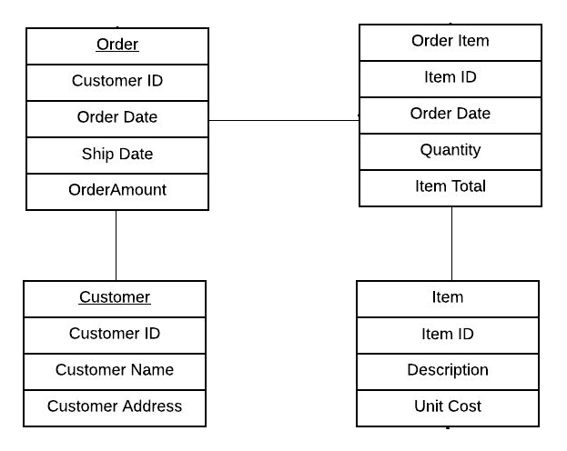
CREATE TABLE CUSTOMER
(CUSTOMERID NUMBER(3) PRIMARY KEY, NAME VARCHAR2(25), ADDRESS VARCHA
CREATE TABLE ITEM
(ITEMID NUMBER(3) PRIMARY KEY, DESCRIPTION VARCHAR2(25), UNITCOST NUMBER(5));
CREATE TABLE ORDER1
(ORDERID NUMBER(3) PRIMARY KEY, ORDERDATE DATE, SHIPDATE DATE,
CUSTOMERID NUMBER (3) REFERENCES CUSTOMER, ORDERAMOUNT NUMBER (5));

CREATE TABLE ORDERITEM
(ORDERITEMID NUMBER(3) PRIMARY KEY,
ITEMID NUMBER (3) REFERENCES ITEM,
QUANTITY NUMBER (4), AMOUNT NUMBER (5),
ORDERID NUMBER (3) REFERENCES ORDER1);
INSERT INTO CUSTOMER VALUES (111, 'HARY MERCHANT', 'NEW JERSEY');
INSERT INTO CUSTOMER VALUES (112, 'MARC ALIGABETH', 'NEW YORK');
Select * from customer;
CUSTOMERID | NAME | ADDRESS
111 | HARY MERCHANT | NEW JERSEY
112 | MARC ALIGABETH | NEW YORK

INSERT INTO ORDER1 VALUES (101, TO_DATE('2014/10/12', 'YYYY/MM/DD') , 111, 12500, TO_DATE('2014/12/12', 'YYYY/MM/DD'));
INSERT INTO ORDER1 VALUES (102, TO_DATE('2015/10/12', 'YYYY/MM/DD') , 111, 12500, TO_DATE('2015/12/15', 'YYYY/MM/DD'));
INSERT INTO ORDER1 VALUES (103, TO_DATE('2015/11/10', 'YYYY/MM/DD') , 112, 12500, TO_DATE('2015/11/12', 'YYYY/MM/DD'));
Select * from order1;
ORDERID | ORDERDATE | CUSTOMERID | ORDERAMOUNT | SHIPDATE
101 | 10/12/2014 | 111 | 12500 | 12/12/2014
102 | 10/12/2015 | 111 | 12500 | 12/15/2015
103 | 11/10/2015 | 112 | 12500 | 11/12/2015

INSERT INTO ITEM VALUES (201, 'LAPTOP', 30000);
INSERT INTO ITEM VALUES (202, 'DESKTOP', 38000);
Select * from item;
ITEMID | DESCRIPTION | UNITCOST
201 | LAPTOP | 30000
202 | DESKTOP | 38000

INSERT INTO ORDERITEM VALUES (901, 201, 50, 15000, 101);
INSERT INTO ORDERITEM VALUES (902, 201, 50, 1500, 102);
INSERT INTO ORDERITEM VALUES (903, 202, 30, 2500, 102);
Select * from orderitem;
ORDERITEMID | ITEMID | QUANTITY | AMOUNT | ORDERID
901 | 201 | 50 | 15000 | 101
902 | 201 | 50 | 1500 | 102
903 | 202 | 30 | 2500 | 102

